**LINUX COMMANDS**

**Check the Date**

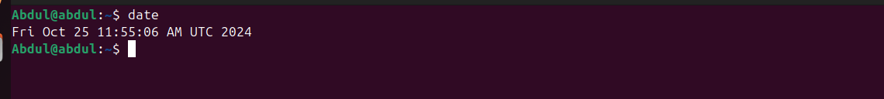

**PWD- Present Working Directory**

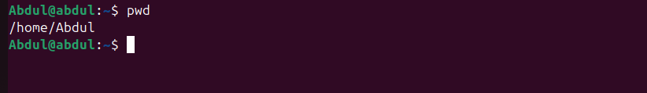

**History – to check the history**

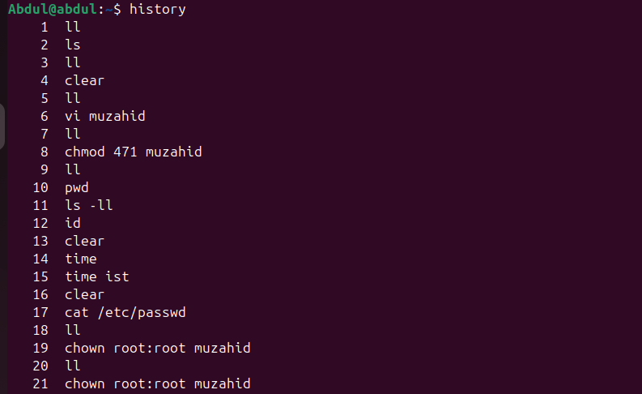

**Clear- used to clear all the commands**

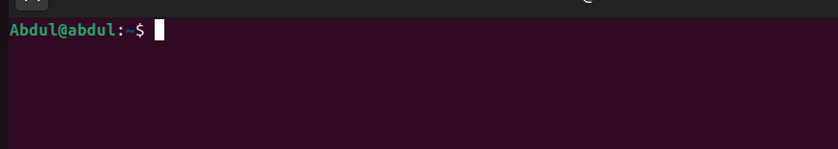

**/ - Root Directory**

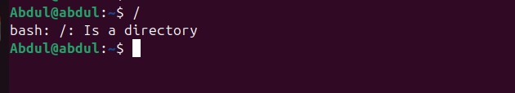

**~ - Home directory**

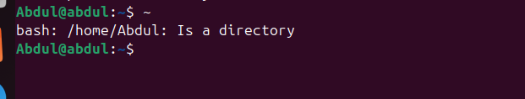

**LS – List of files**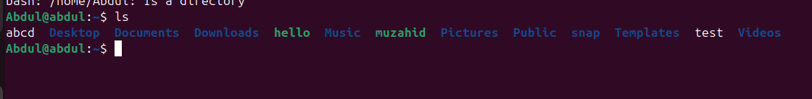

**cd.. – one step back**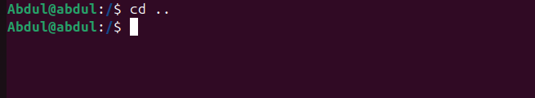

**Cd ../.. – two steps back**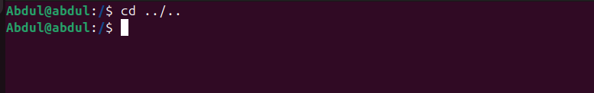

**Ls – l - long list**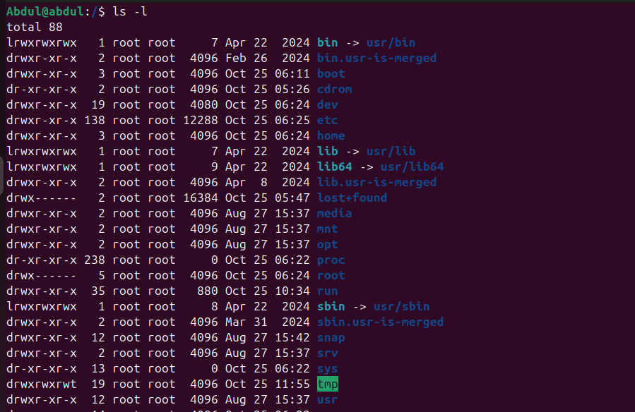

**LL – get all thye files which available at that place**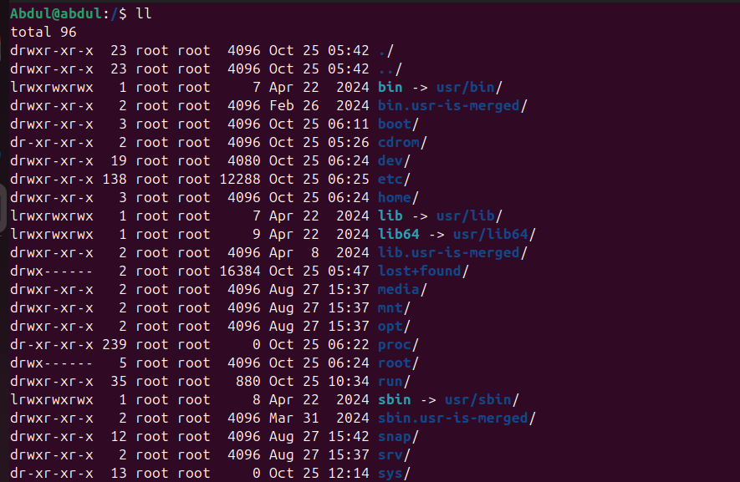

**touch – used to create a file with zero bytes**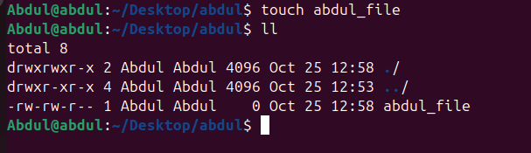

**mkdir – used to create a directory**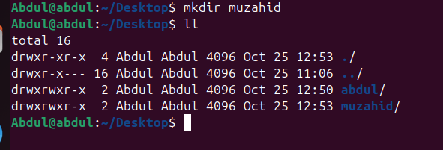

**vi - Create a file and cat check the inside data**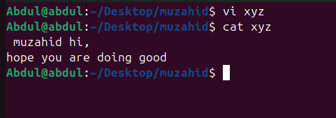

**rm - Remove**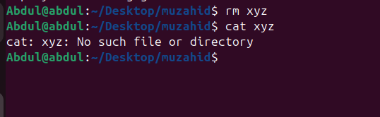

**Complete details of system**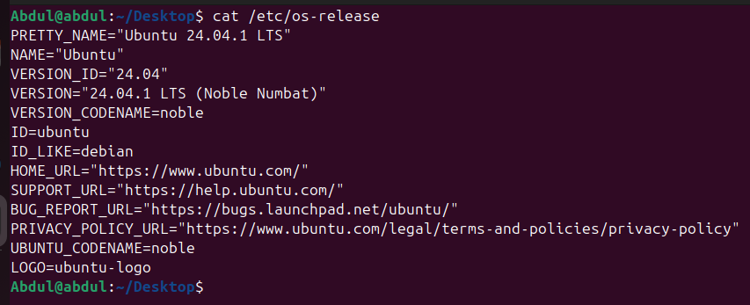

**Complete details of the hardware**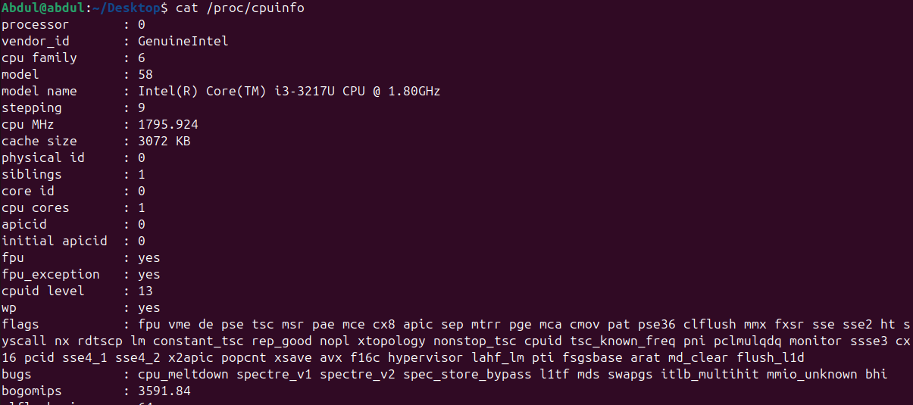

**How many users available in server**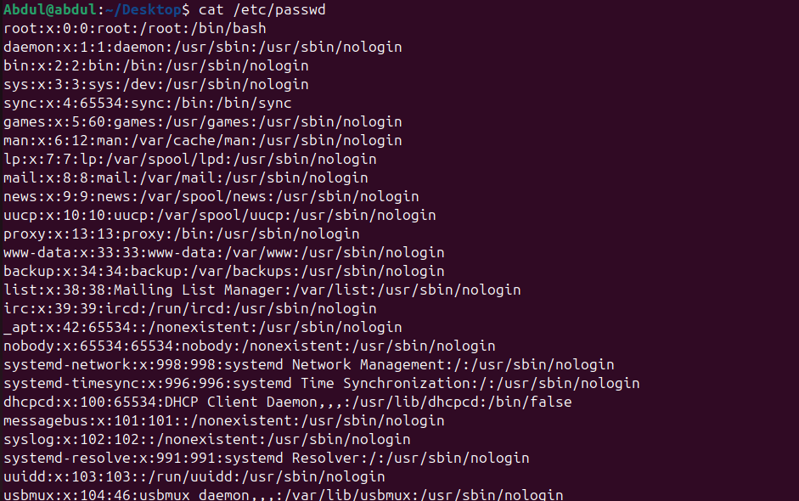

**sudo- any command is not working twhn use sudo at that time command will run  
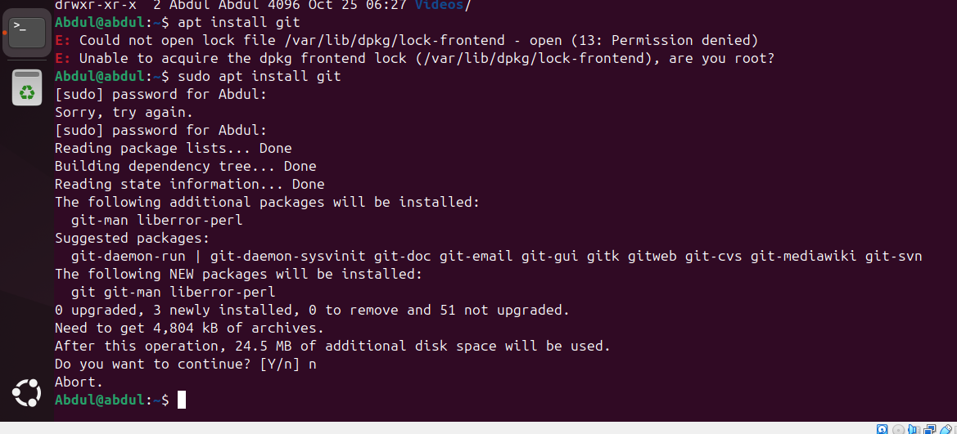**

**modification of file permission  
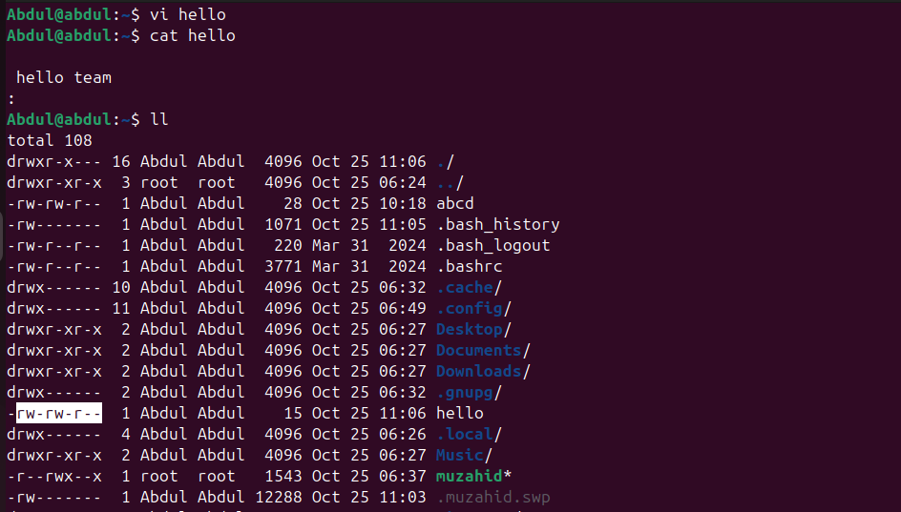**

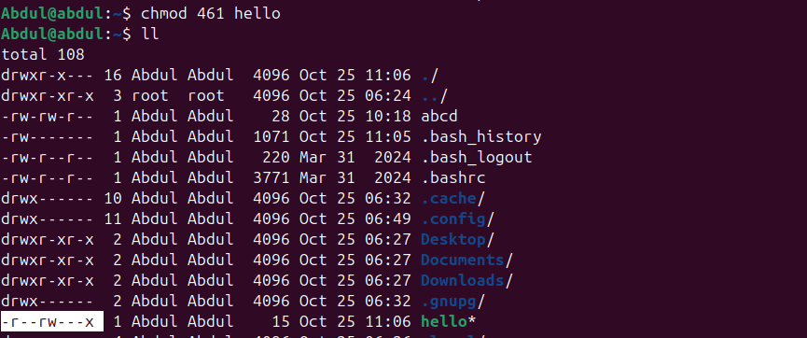

**Find the file which is sudoers available  
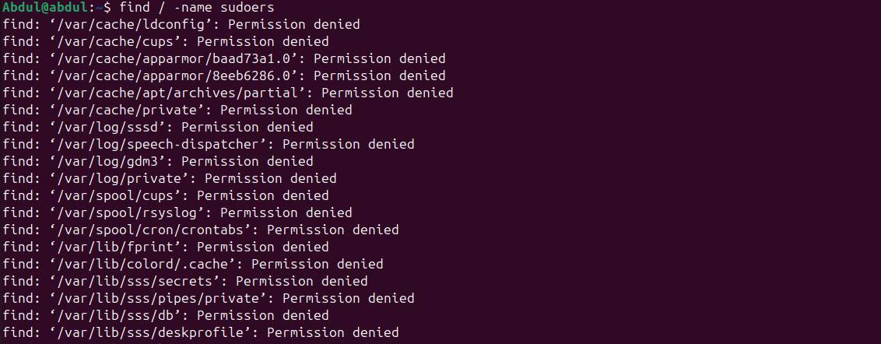**

**Redirection  
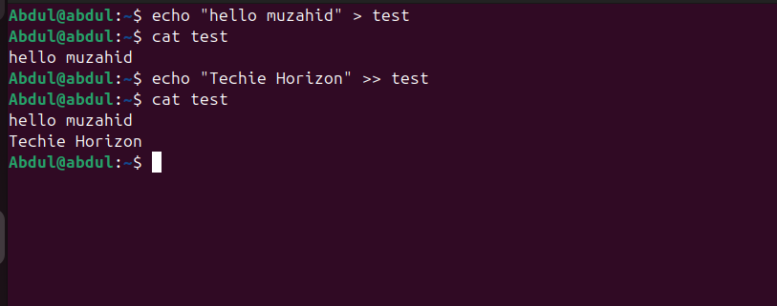**

**Check the number of lines in a file**

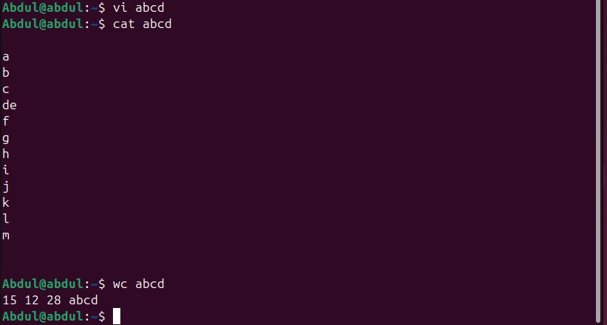

**Read top particular line and bottom Particular Lines**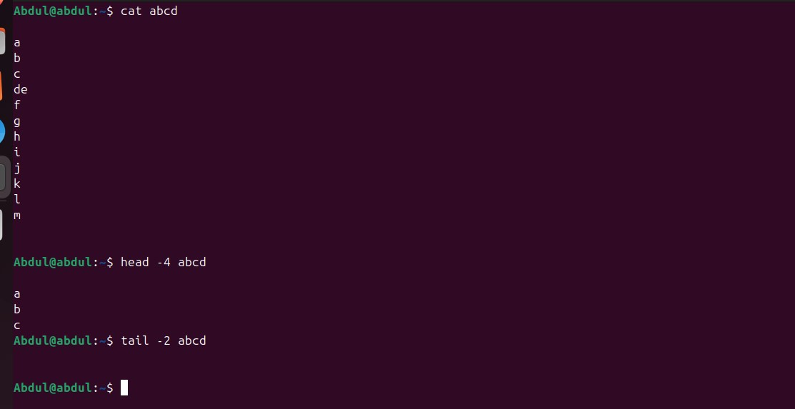

**Id, uname, echo $0  
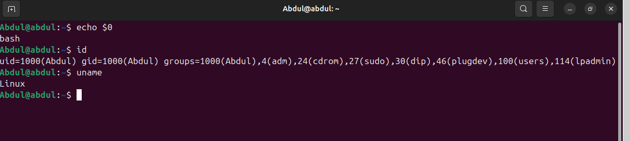**

**Grep**

